**2100032467**

**U. Ashitha**

**Cloud & Serverless Computing**

**-------------------------------------- ----------------------------------**

**Home Assignment-3(Project Documentation)**

**Converting Speech to Text Using Amazon Transcrobe With S3 integration**

**Procedure**

1. **Upload Audio File to S3 Bucket**: Begin by uploading the audio file that you want to transcribe to an Amazon S3 bucket. You can use the AWS Management Console, AWS CLI (Command Line Interface), or AWS SDKs (Software Development Kits) to upload the file.
2. **Configure S3 Bucket Permissions**: Ensure that the S3 bucket has the necessary permissions to allow AWS Transcribe to access the audio file for transcription. You may need to set up IAM roles and policies to grant Transcribe the required permissions.
3. **Create a Transcription Job**: Navigate to the AWS Transcribe service in the AWS Management Console. Select "Create transcription job" and provide details such as the name of the job, the language of the audio content, the location of the audio file in the S3 bucket, and any additional settings like vocabulary customization or speaker identification.
4. **Monitor Transcription Job**: Once the transcription job is created, you can monitor its progress in the Transcribe console. Transcribe will automatically process the audio file and generate the corresponding text transcription.
5. **Retrieve Transcription Results**: After the transcription job is complete, you can retrieve the transcribed text from the output generated by AWS Transcribe. This text can be downloaded from the Transcribe console or accessed programmatically using AWS SDKs or APIs.
6. **Optional: Configure Output Settings**: AWS Transcribe allows you to configure various output settings, such as specifying the format of the transcribed text (e.g., JSON, plain text), enabling timestamps, and selecting the location to store the transcription output. You can customize these settings based on your requirements.
7. **Review and Refine Transcription**: Once you have the transcribed text, review it for accuracy and make any necessary edits or refinements. While AWS Transcribe is highly accurate, it may occasionally misinterpret certain words or phrases, especially in noisy or complex audio environments.
8. **Integrate Transcription Output**: Finally, integrate the transcribed text into your desired applications or workflows. You can use the text for various purposes, such as generating subtitles for videos, indexing audio content for search, or extracting insights from spoken data for analytics.

**Screenshots of Procedure**

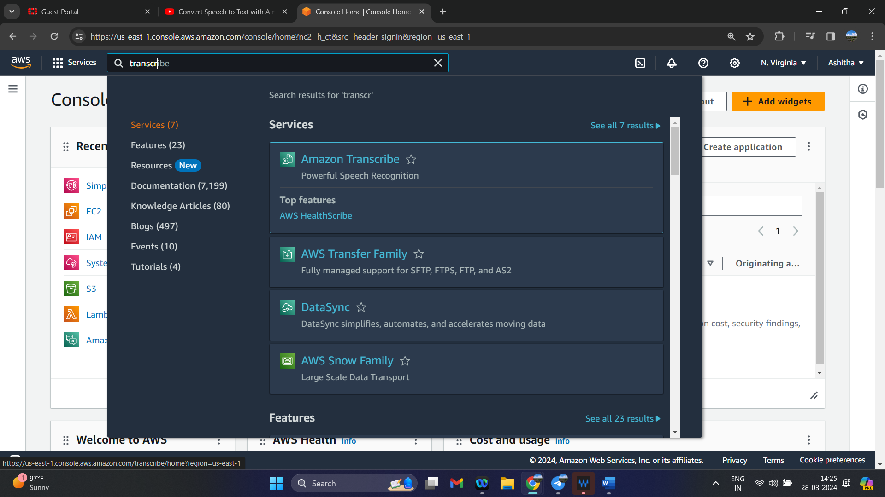

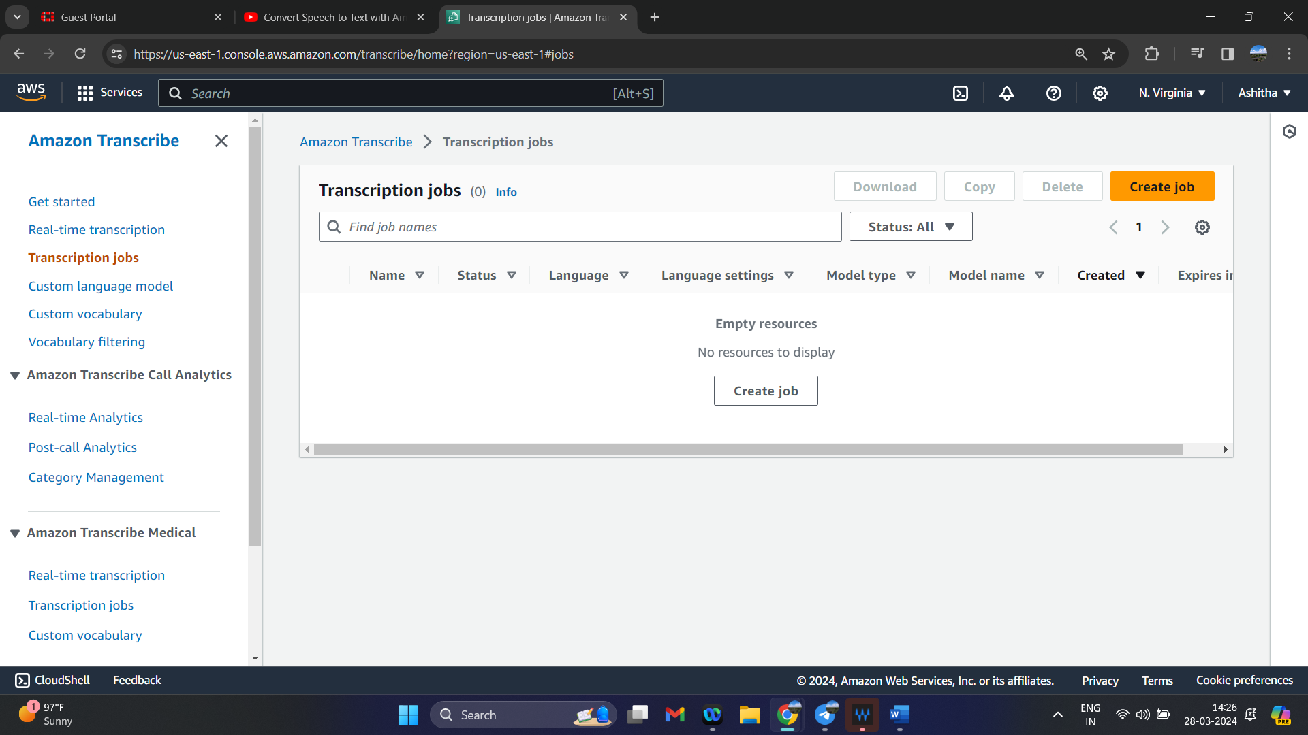

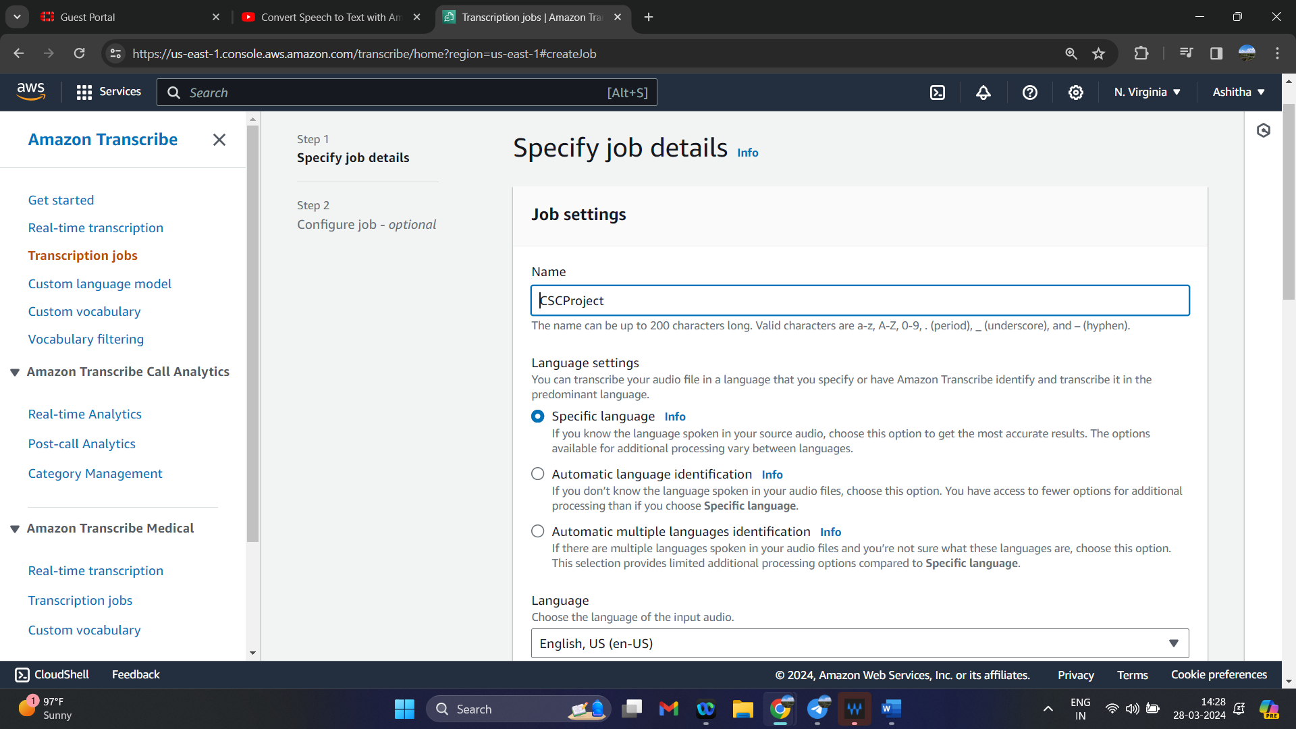

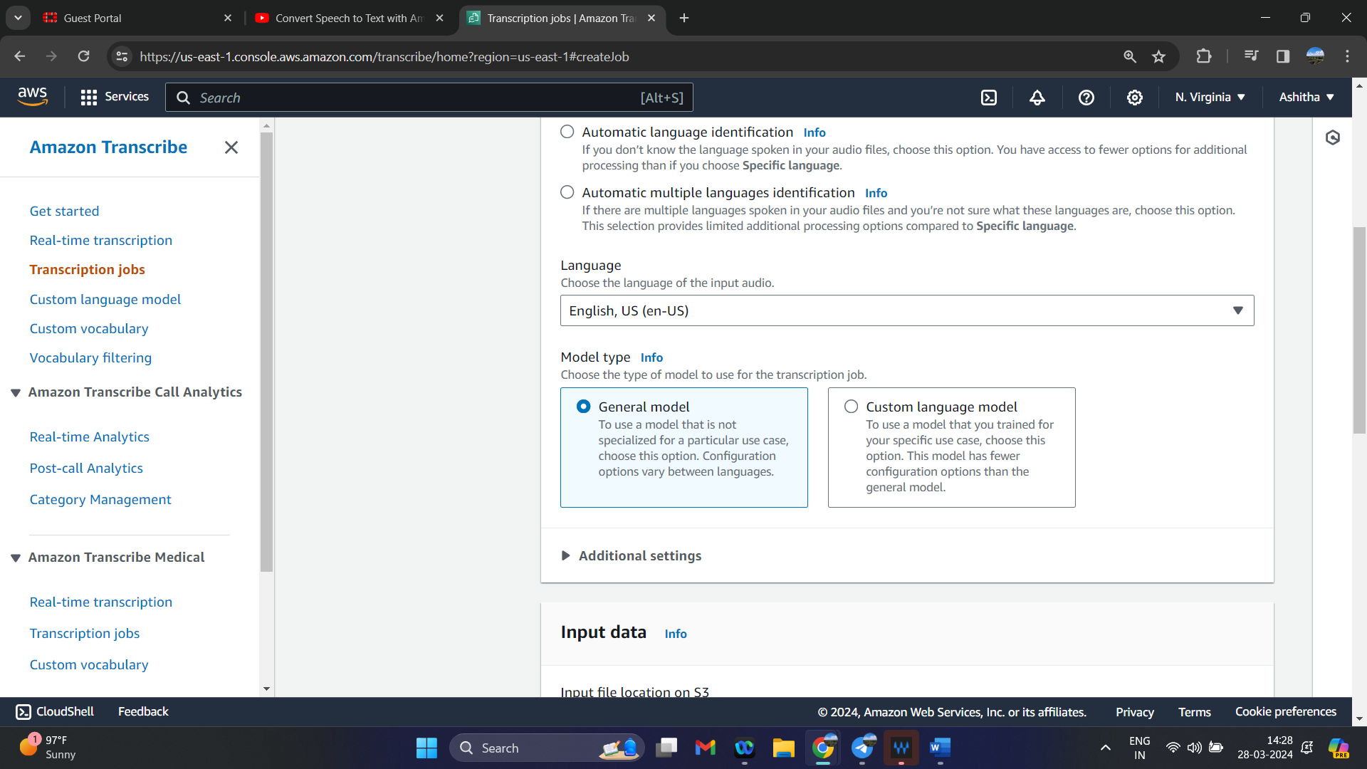

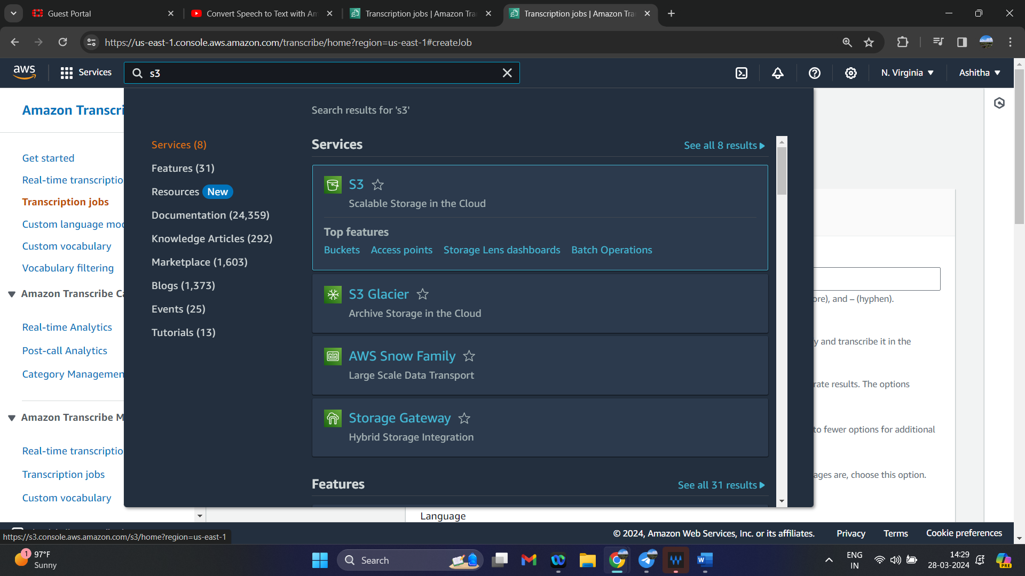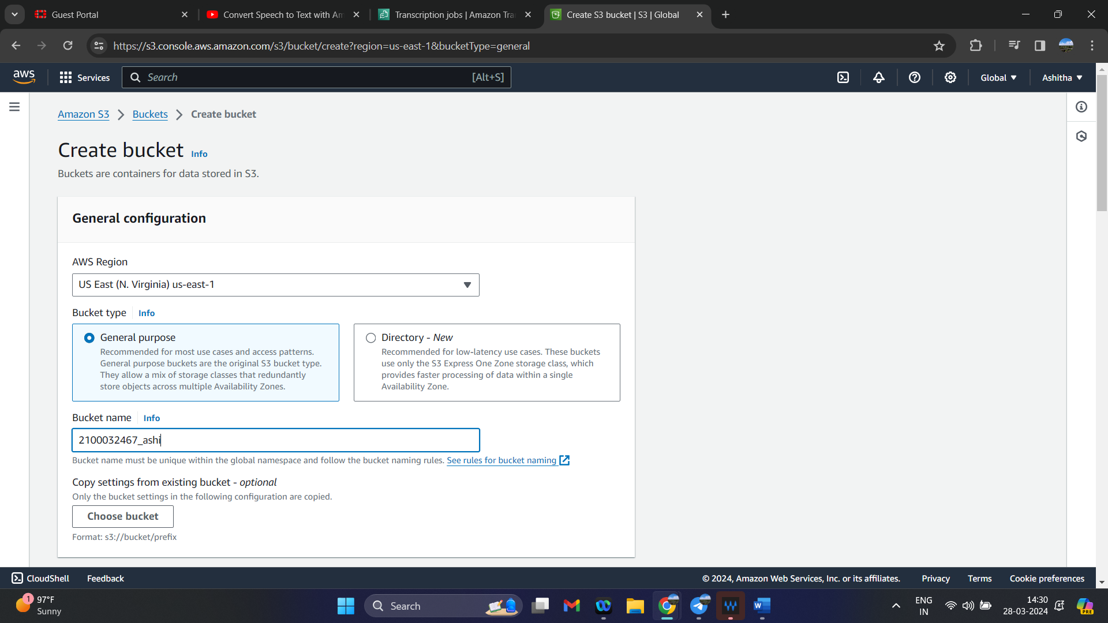

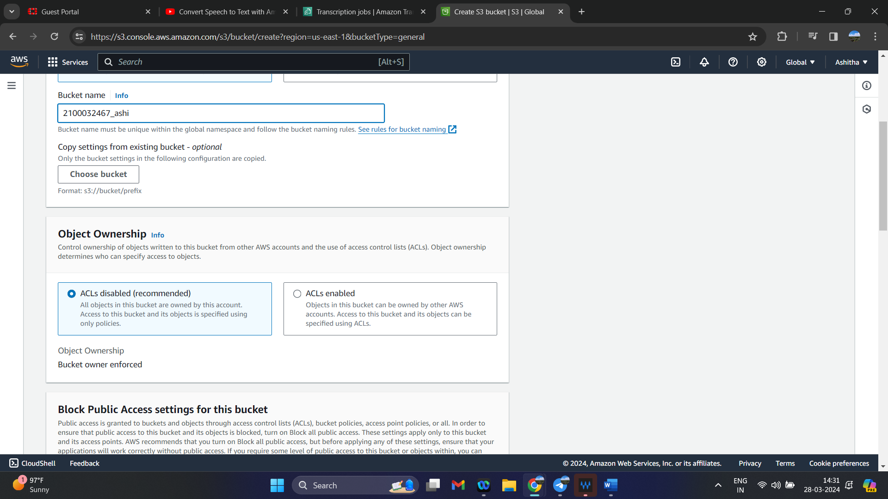

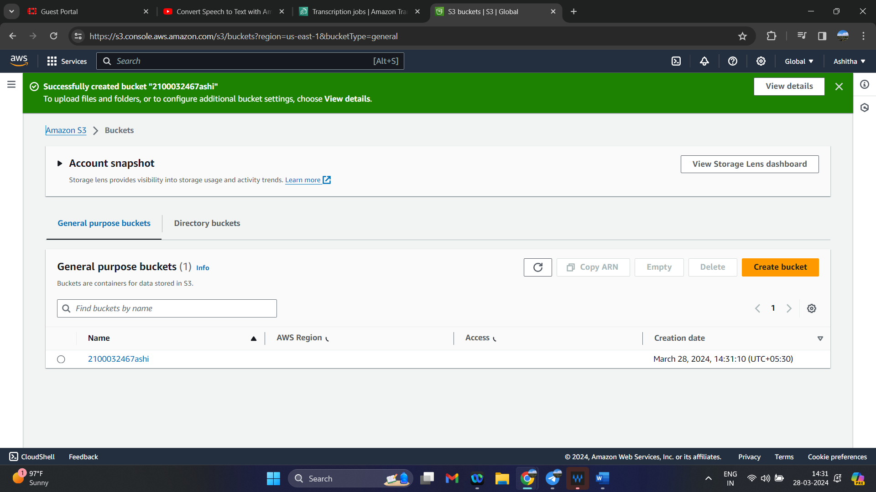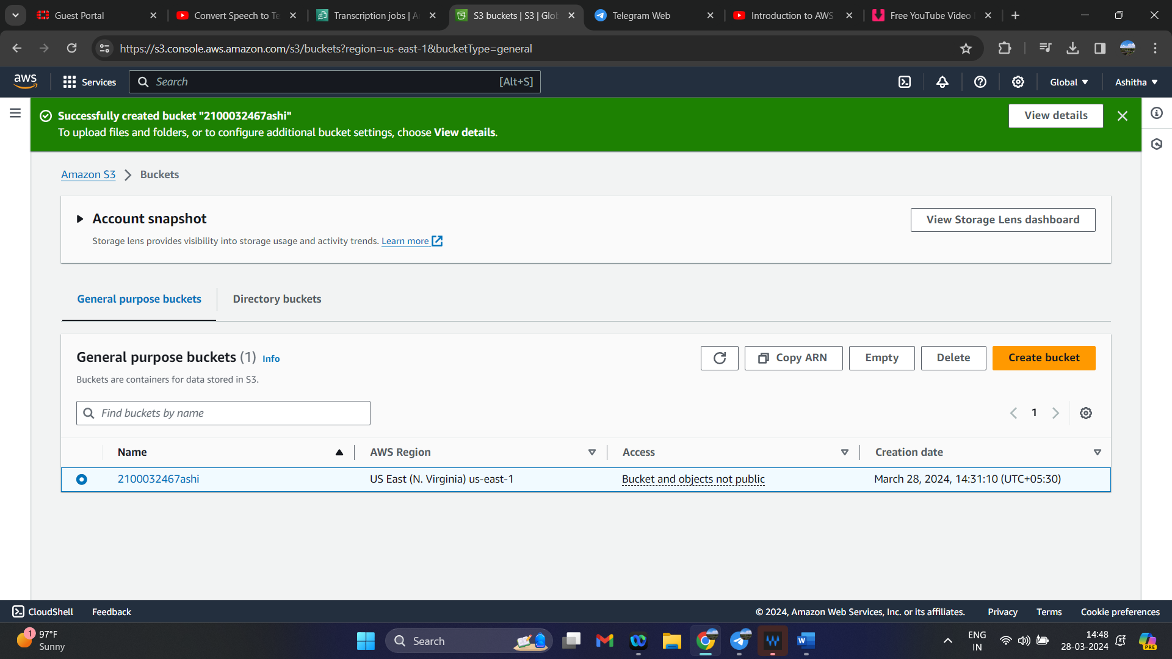

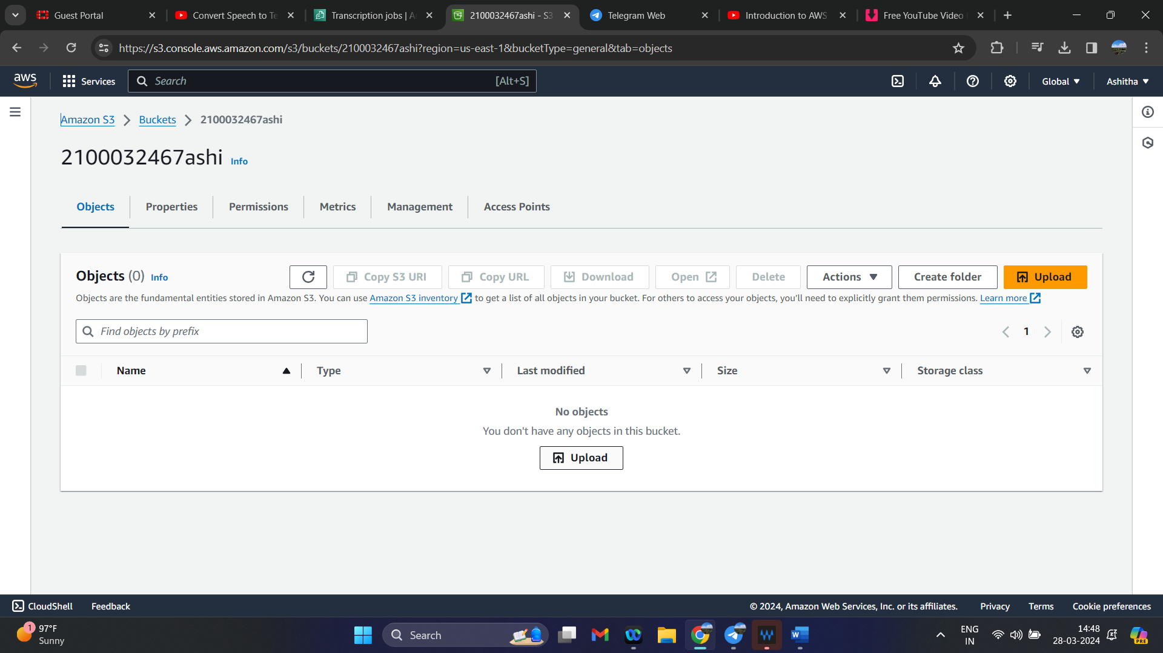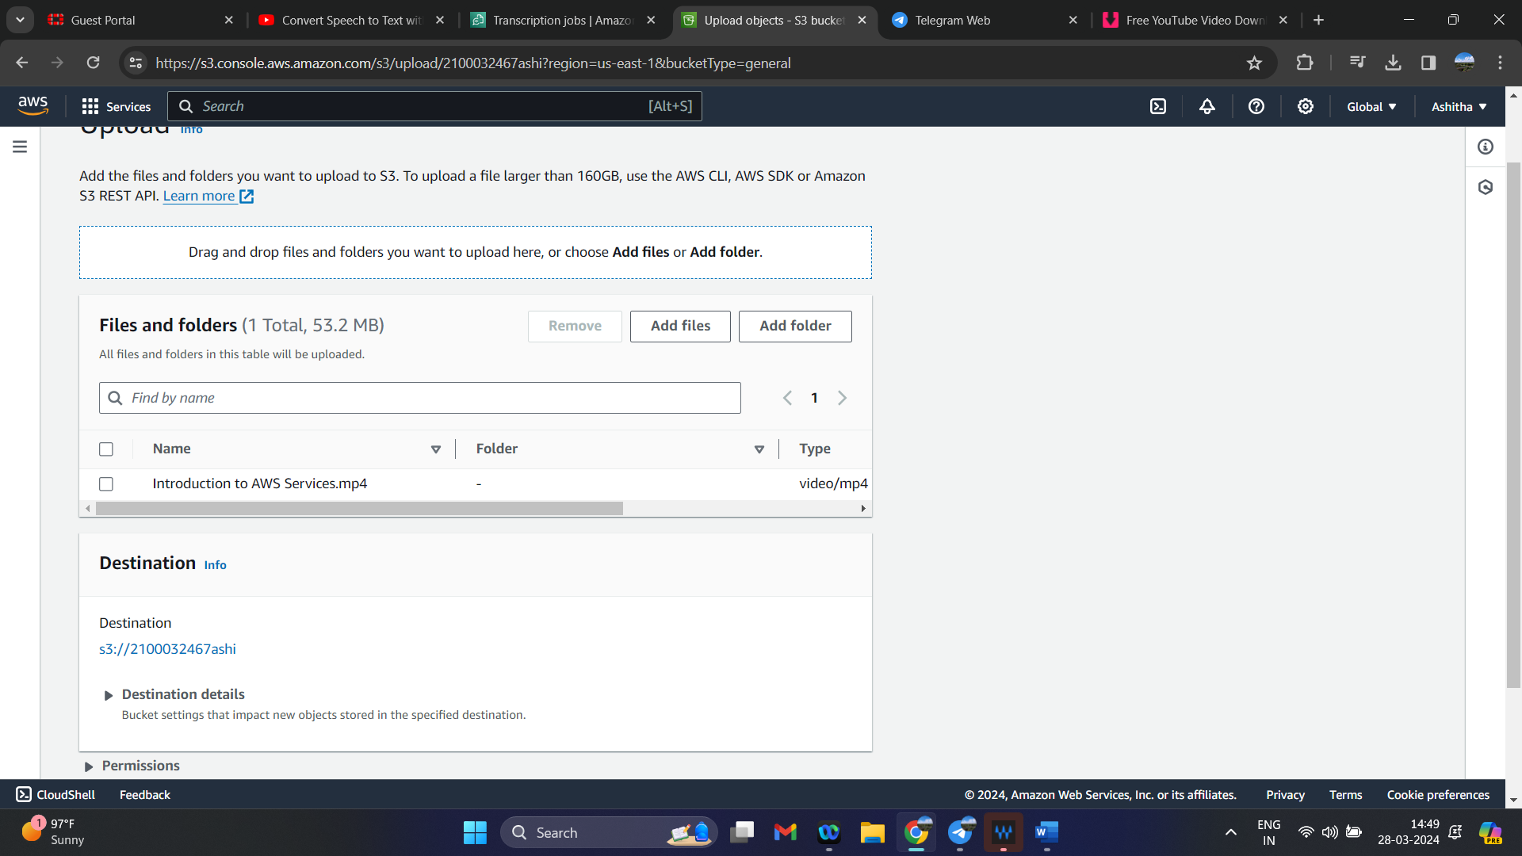

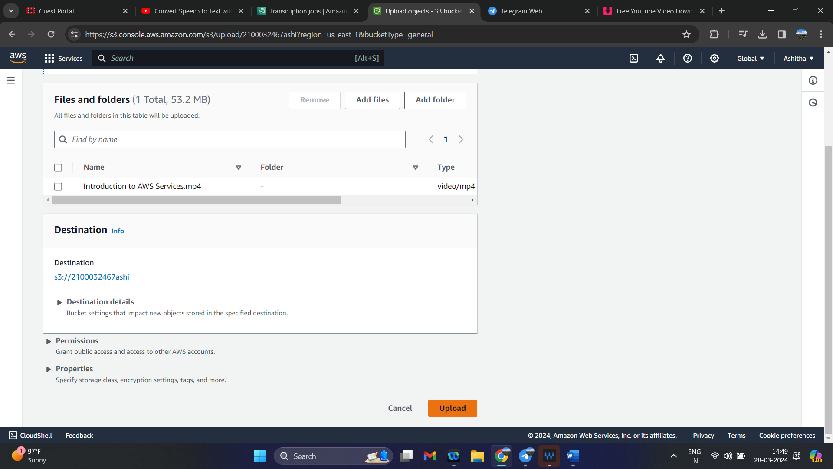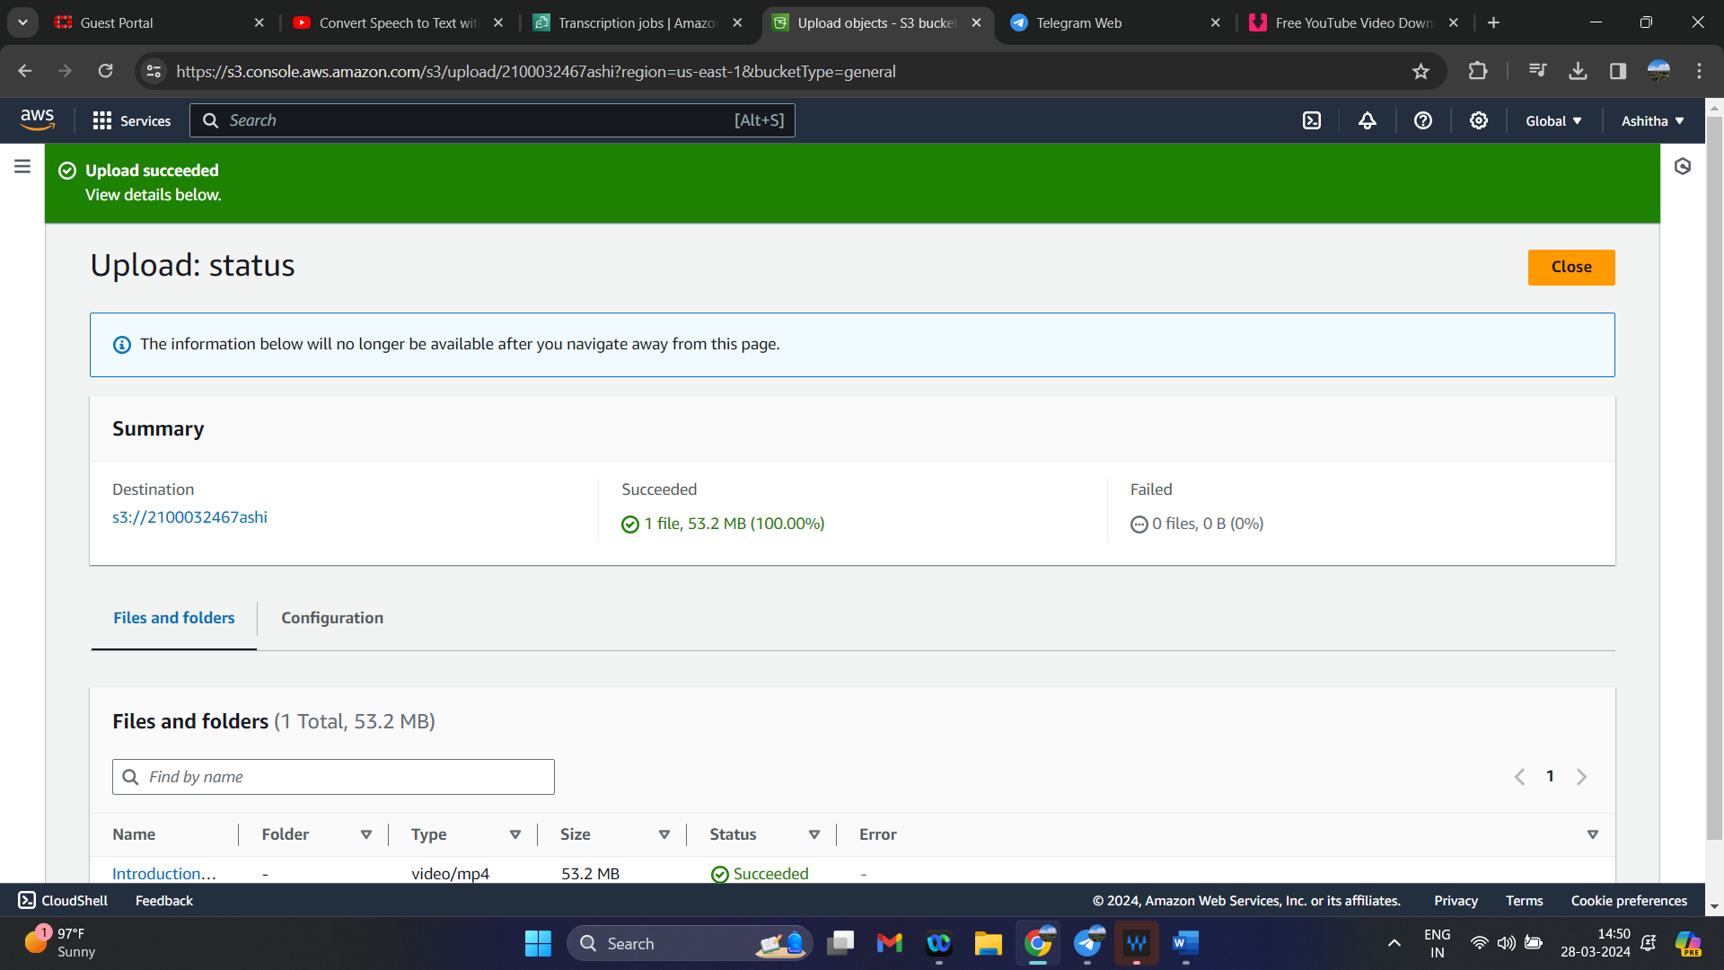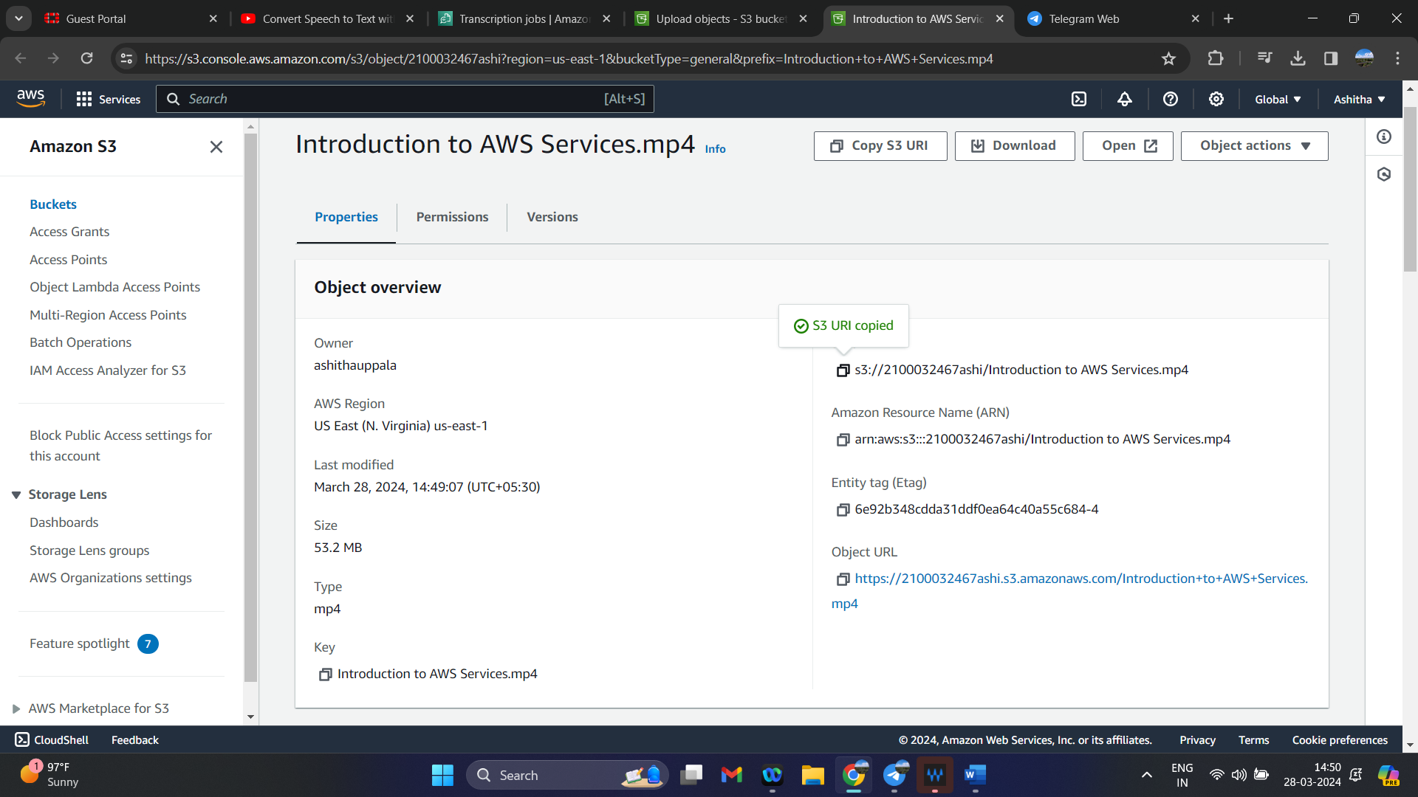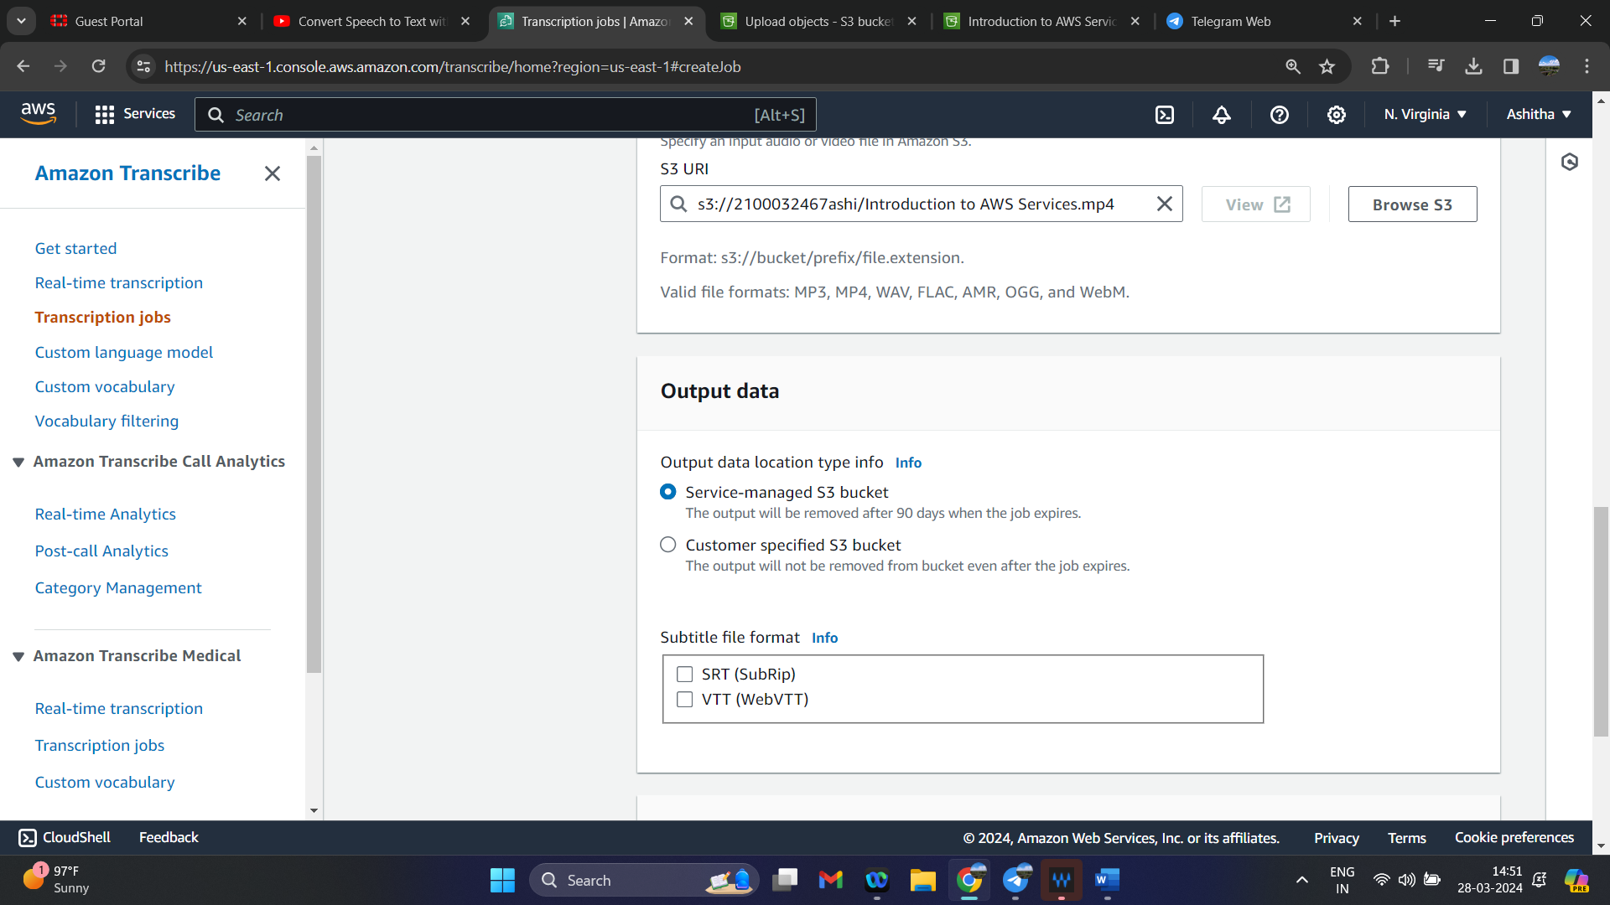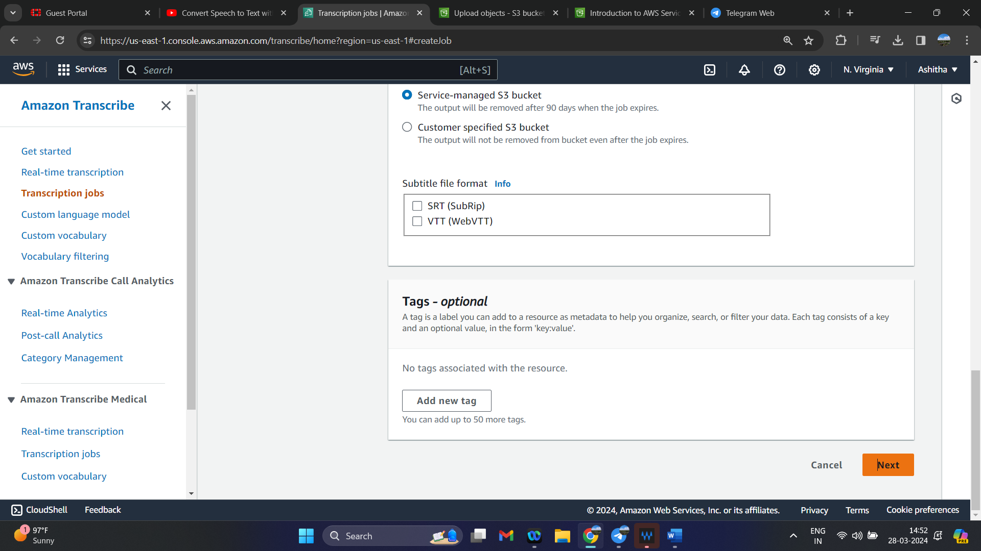

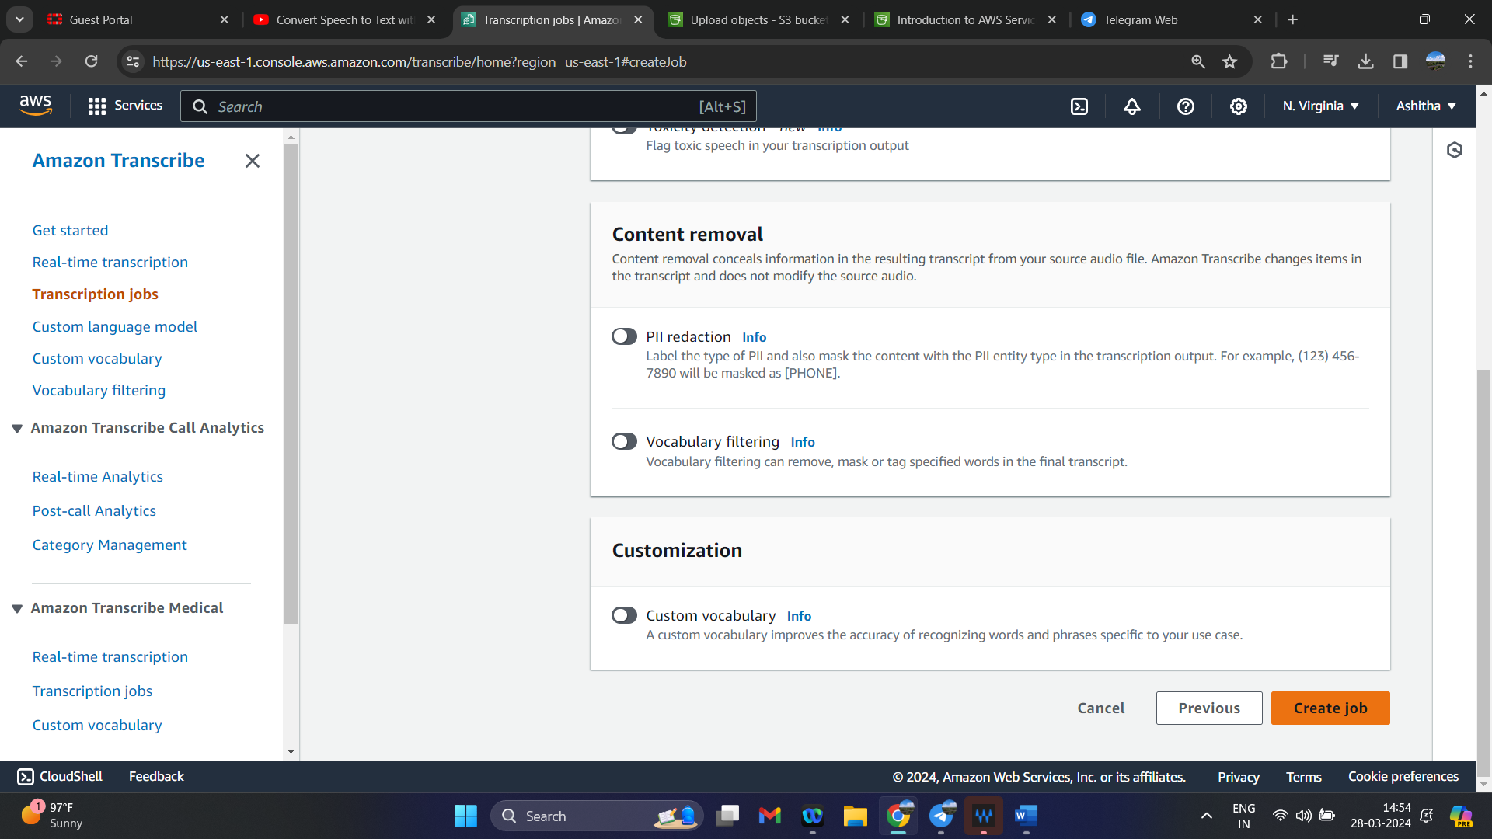

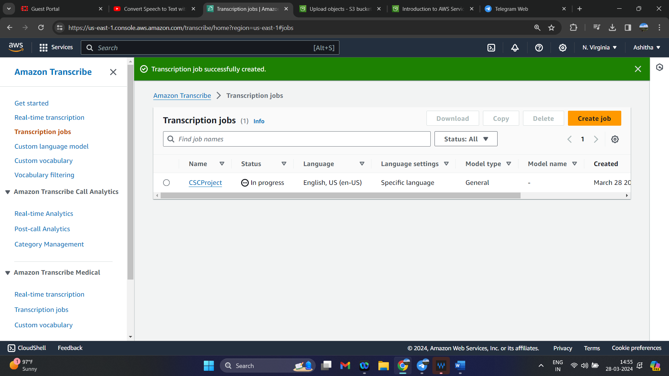

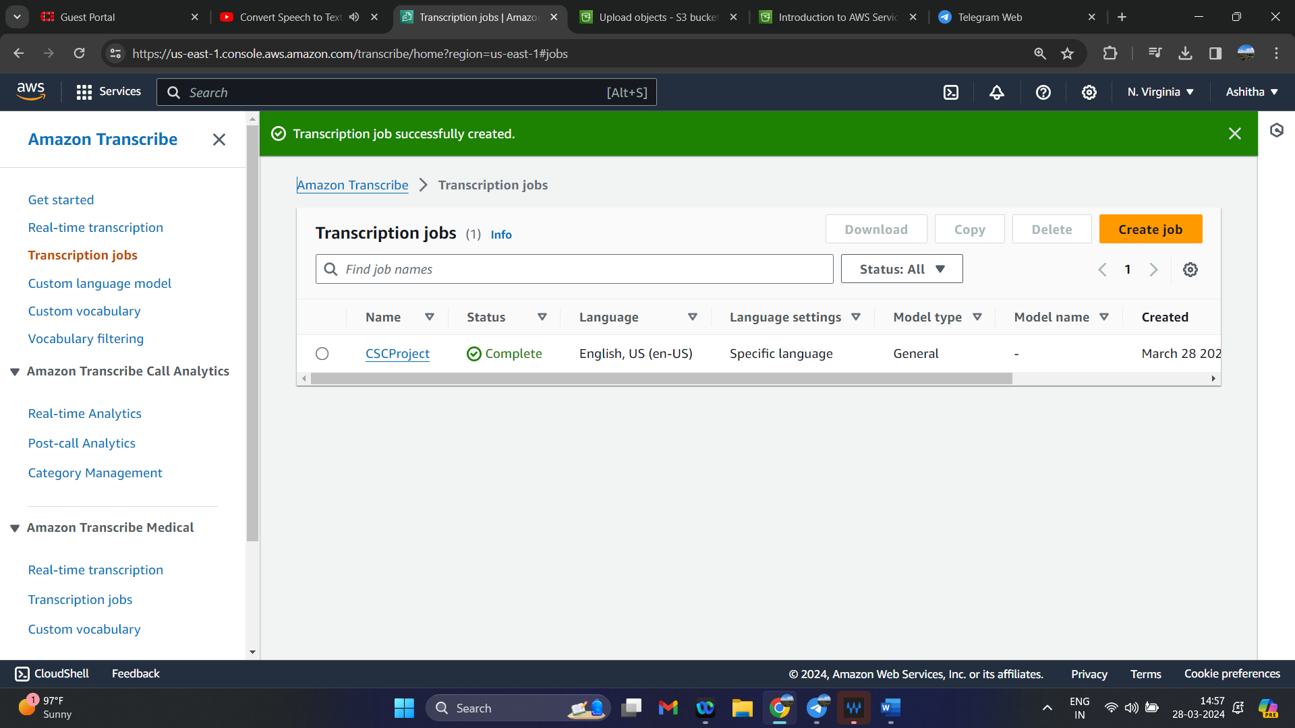

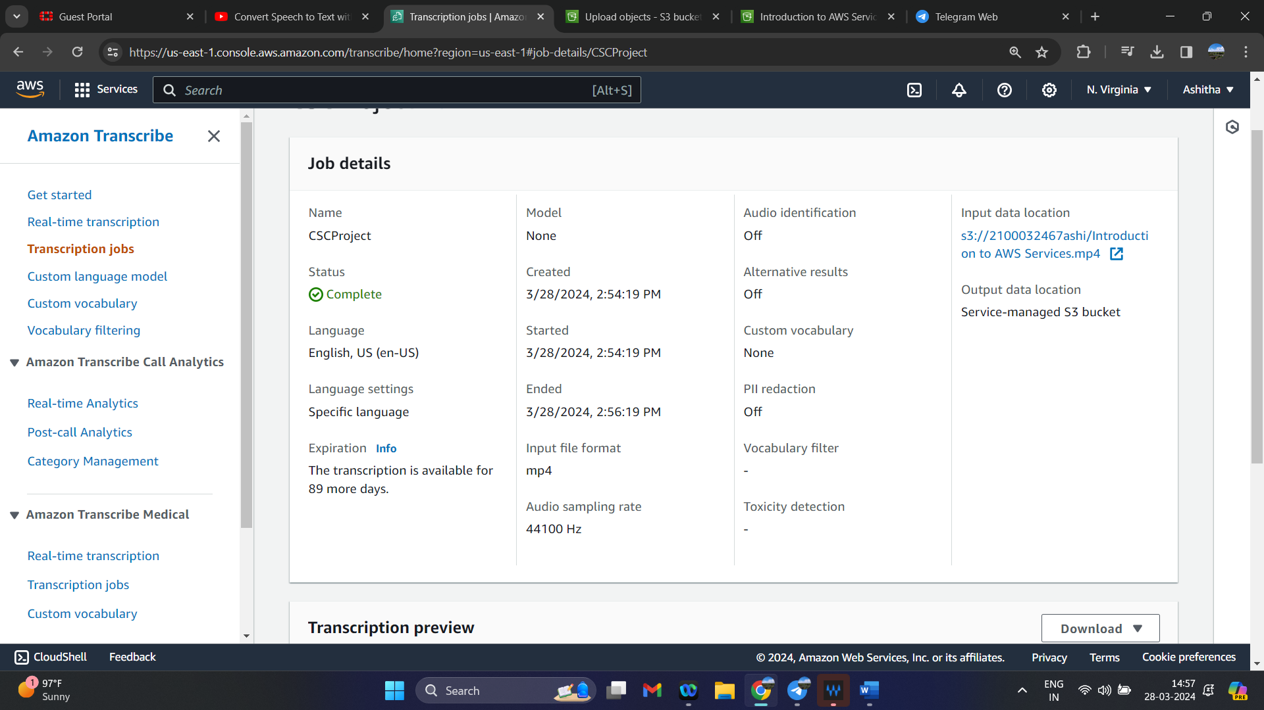

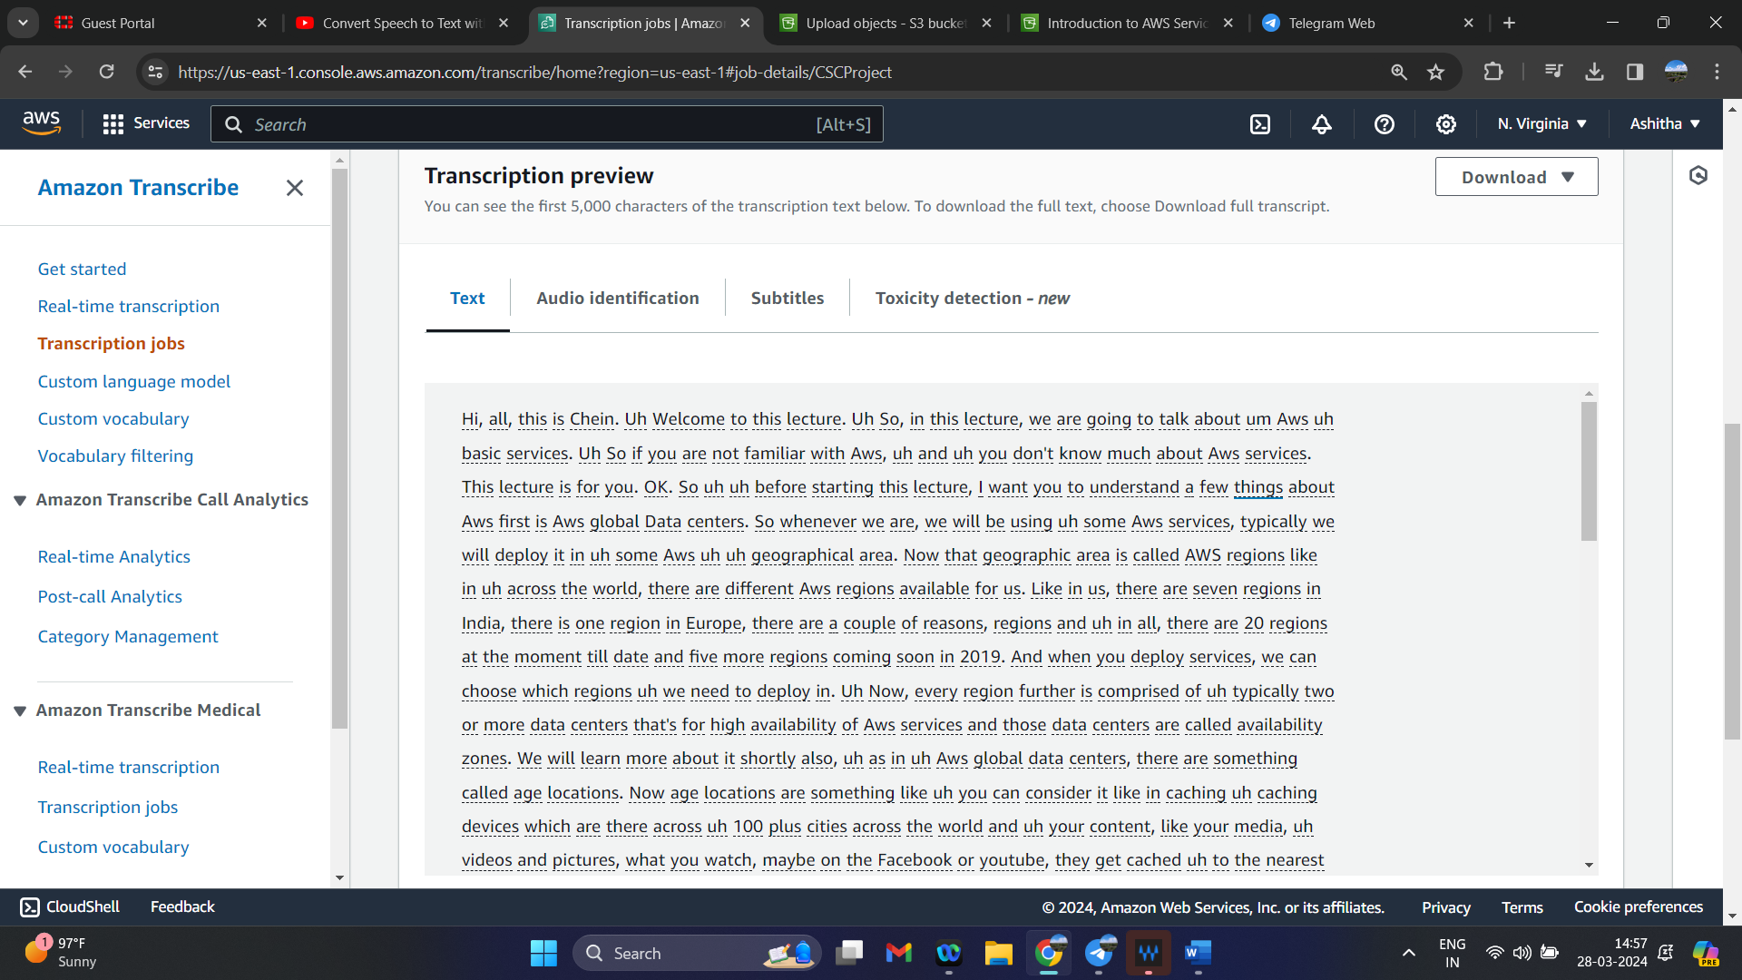

**Architecture**

